# Student-Teacher Appointment Booking System

1. **Executive Summary:** In the dynamic landscape of education, effective communication between students and teachers is paramount for academic success. This report outlines the implementation of a Student-Teacher Appointment Booking System, aimed at streamlining the scheduling process and fostering better collaboration between students and teachers.
2. **Introduction:** Traditional methods of scheduling appointments, such as email exchanges or in-person sign-ups, can be cumbersome and inefficient. The Student- Teacher Appointment Booking System is designed to provide a user-friendly and efficient platform for students to schedule appointments with their teachers.

# Objectives:

* + Facilitate convenient appointment scheduling for students and teachers.
  + Reduce administrative burden on staff related to appointment coordination.
  + Enhance communication between students and teacher.

**3.1 System architecture**

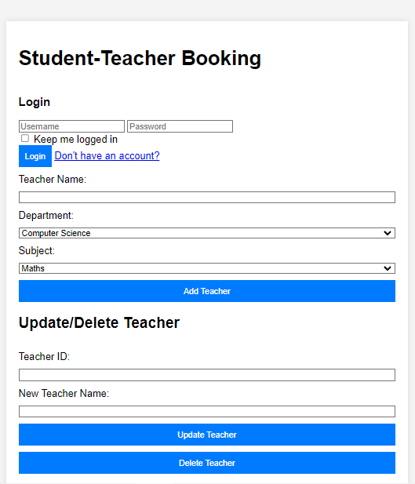

1. **Features of the System:**
   1. Admin Section: Add Teacher:

Admin can add teachers with name, department, and subject details. Admin can update or delete teacher details.

* 1. Teacher Section:

Login:

Teachers can log in to their accounts. Schedule Appointment:

Teachers can manage their appointment schedules. Approve/Cancel Appointment:

Teachers can approve or cancel appointment requests. View Messages:

Teachers can view messages sent by students. View All Appointments:

Teachers can view a list of all appointments.

# Implementation:

* + The system allows to have teacher login.It includes three main sections: Admin, Teacher, and Student, each catering to specific functionalities

# Benefits:

* + **Time Efficiency:** Reduces time spent on scheduling through an automated and centralized system.
  + **Increased Accessibility:** Allows students to schedule appointments at their convenience.
  + **Enhanced Communication:** Facilitates clearer communication between students and teachers.
  + **Data Collection:** Provides data on appointment frequency, types, and reasons, aiding in understanding student needs.

# Challenges and Mitigations:

* + **Technological Barriers:** Adequate support and training will be provided to overcome technological challenges.
  + **Resistance to Change:** A comprehensive communication plan will be implemented to address concerns and highlight the benefits of the new system.

# Future Improvements:

* + **Integration with Learning Management Systems:** Seamless integration with existing systems to further streamline academic processes.
  + **Mobile Application:** Development of a mobile application for increased accessibility.

1. **Conclusion:** The Student-Teacher Appointment Booking System represents a significant step towards fostering improved communication and collaboration within the educational institution. By leveraging technology to simplify administrative processes, the system aims to create an environment conducive to academic success and student support.

# Recommendations:

* + Regularly solicit feedback from users for continuous improvement.
  + Explore opportunities for further integration with existing educational technologies.

This report concludes that the implementation of a Student-Teacher Appointment Booking System has the potential to enhance the overall educational experience by promoting efficient communication and collaboration between students and teachers.